We used the simulation of the hydrogen atom from the University of Nebraska (<http://astro.unl.edu/naap/hydrogen/animations/hydrogen_atom.html>) to fire photons at the atom. Below is a screen shot showing what a student sees.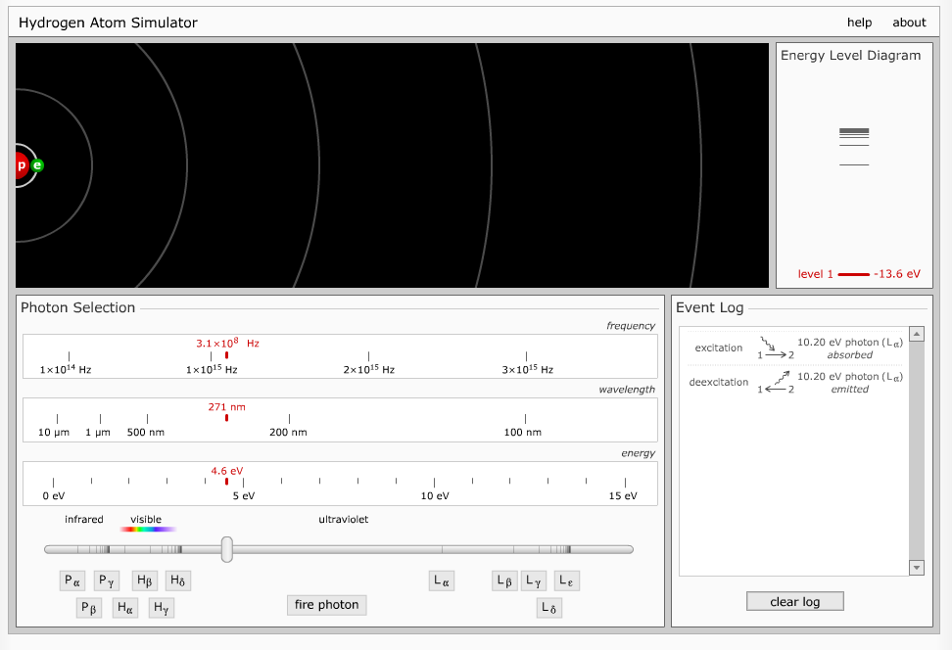

Key features from this simulation to include in the new simulation:

* Drawing of the nucleus with electron in n=1 and with states shown as circles
* Energy level diagram on the right
* Slider bar to select photon by either energy, wavelength or frequency
* Nice to have the IR, visible, and UV ranges noted along the slider scale
* Event log that does not automatically go away telling what happens (can be reset)
* Time delay for transition back to ground
* Multiple ways to transition back that students can see
* Photons depicted as wave packet with the associated color and size wavelength
* Buttons corresponding to the wavelengths for Lyman, Balmer, and Paschen series (they are discussed in the video)

It would be nice to change the energy diagram.

The movements up and then down are shown but the sequence cannot be displayed. The transitions are shown but then they go away. It would be great to have the sequence up and down stay fixed until the student could manually clear or reset the energy level display. Then the student could see the transitions going up and the associated ones going down on the vertical diagram with the numerical energies marked for the levels of movement between excited states.